AWEC Membership Form

Include a resume and organizational chart with application
First Name
Last Name
Title |  | Work Phone
Email
Address
City
State |  | Zip Code
Current Position
Payments are accepted by credit card, check, or thru pay pal Send To:
If charging payment provide the following: __AMEX ___ MC ___VISA ___Discover Francine Perretta, Executive Director
Card#____________ Security code__________ Zip code___________ 8 Stiles Rd, Canton, NY 13617 info@awec.us
Name on card: ________________________________________________________
Exp. Date: _______________ Amount: ________________
Signature: __________________________________________________________
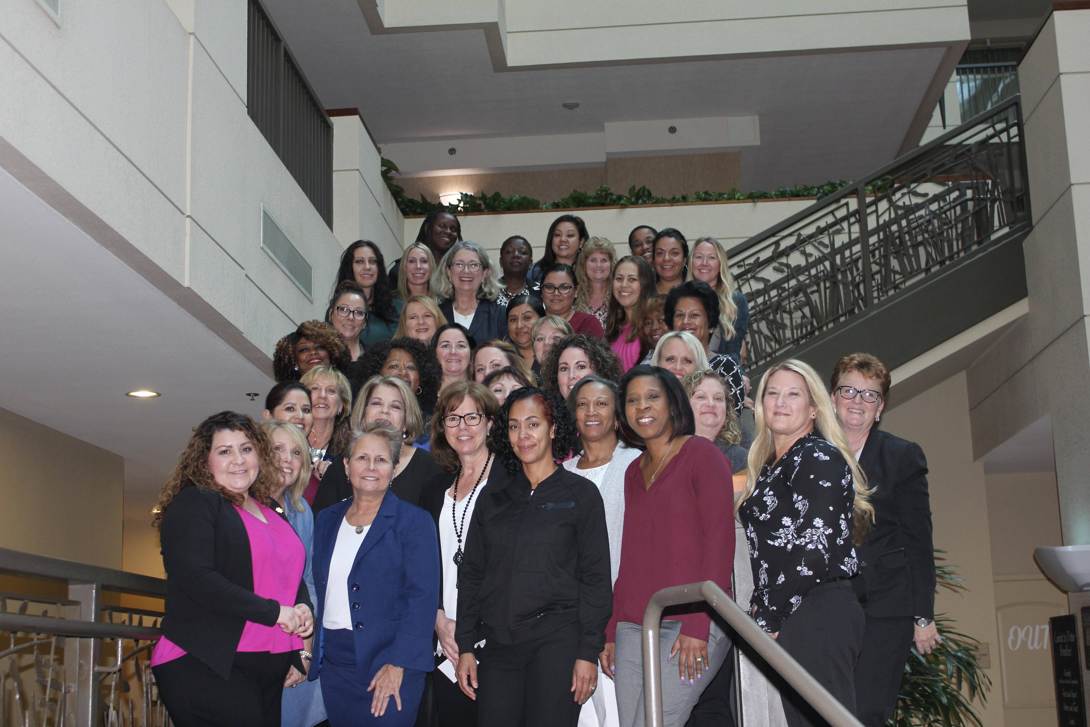
HISTORY

AWEC was born out of the desire of correctional trailblazers to increase the leadership skills of female correctional executives and to develop the future generation of women leaders. The charter members in 1996 passed a constitution, and adopted a mission statement and elected their first officers. With membership over 650, AWEC has become a dynamic professional organization where executive women in corrections can network with their peers, enhance their skills and mentor future female correctional leaders.

MISSION

Our mission is to provide leadership development for executive women, support the career advancement of women in corrections, and promote informed discussion of correctional issues in an atmosphere of mutual respect.
VALUES

- Developing women as executive leaders will enhance the effectiveness of the correctional field.
- Power of relationships is the foundation for success.
- Encouraging, mentoring and modeling women will provide the support in their efforts to achieve their full potential.
- Trust, respect, and integrity are inherent qualities for executive leadership.
Diversity in membership, ideas and perspectives enriches the Association

Individual and Associate Membership Agency Membership
- $125 for 1 year Agency fee is $125 per member on agency invoice
- $75 for 1year retirees

- $50 for 1year retirees

AWEC is the active voice of Women Executives in Corrections working toward reasoned change and development of future leaders

